Criterion C: Development

- External Libraries
- General Coding Terms
  - GUI Components
  - Encapsulation
  - Recursion
  - Inheritance
- File Reading/Writing
- Item Methods
  - Adding/Editing
  - Deleting
  - Searching
  - Sorting
- Error Handling

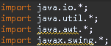
External Libraries

The external libraries imported for the code come from these four main libraries. The java.io library was used in the Methods and MainMenu classes to access the File, FileWriter, and PrintWriter classes. The java.util library was used in the Methods, MainMenu, AddWindow, and EditWindow classes to access the ArrayList<E> class and Scanner class. The java.awt and javax.swing libraries were used in the MainMenu, AddWindow, and EditWindow to extend the JFrame class for access to various GUI components.

General Coding Terms
GUI Components
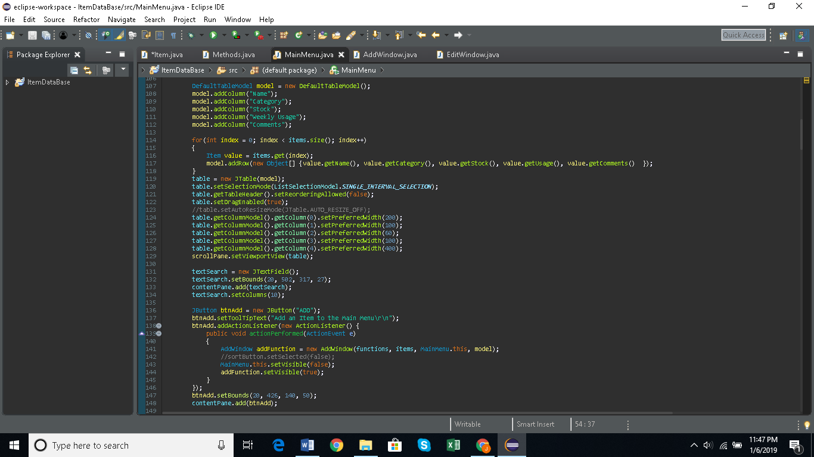
A Graphical User Interface (GUI) allows users to interact with computers through windows, icons, and visual indicators. It is the main layout of the program made easily by Eclipse’s WindowBuilder plugin. This includes user interactive features such as tables, labels, buttons, and text fields. They were initialized and utilized within the MainMenu, AddWindow, and EditWindow classes.

*An example of a JTable model and JButton being initialized and added onto the content pane of a JFrame in the MainMenu class.
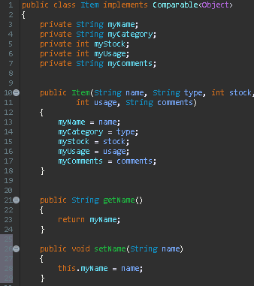
Encapsulation
Encapsulation is an essential in object-oriented programming (OOP) that involves the assignment and use of private variables in a specific class. An example is the Item class and all the private variables that were initialized and used in the accessor methods (get) and mutator methods (set).

Recursion
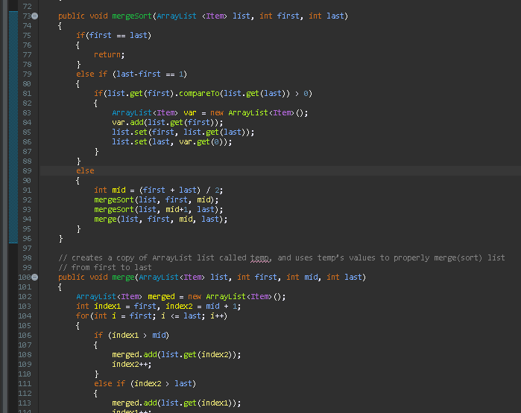
Recursion is the technique in which a method calls itself over and over again to solve a problem. It was used in the mergesort() method in the Methods class to quickly sort the list of Items by their name values alphabetically.
Inheritance
All GUI classes (MainMenu, AddWindow, EditWindow) extend the JFrame class and thus get access to its methods and can create their own JFrames. This allows each class to create their own pop-up windows for the user to input information into.
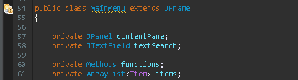

File Reading/Writing
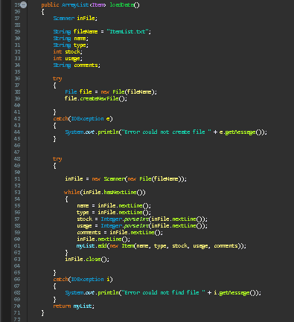
All of the data for the program was saved to an external text file. The text file allows for data to be easily stored and edited. This is done through the File, FileWriter, and PrintWriter classes.

In the loadData() method in the Methods class above shows how data is read from the created text file “ItemList.txt” and loaded into the ArrayList<Item>myList.
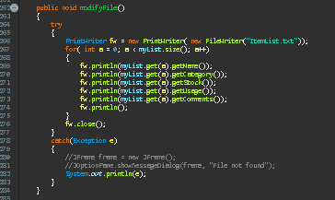
In this example, it shows the modifyFile() method also located in the Methods class. It uses the FileWriter and PrintWriter classes to write into the text file “ItemList.txt” using data from the ArrayList<Item>myList.

Item Methods
Adding/Editing
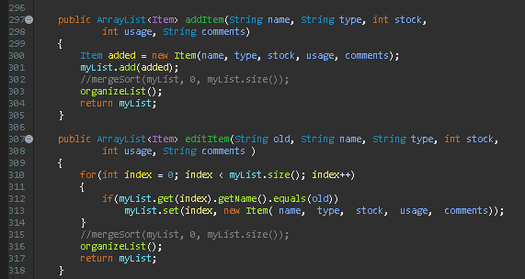
An Item is added and edited using the two methods (addItem() and editItem() captured below) found in the Methods class.

The input for each method comes from the user in the GUI classes, AddWindow and EditWindow, where the information is taken from textfields and comboboxes the user interacts with.

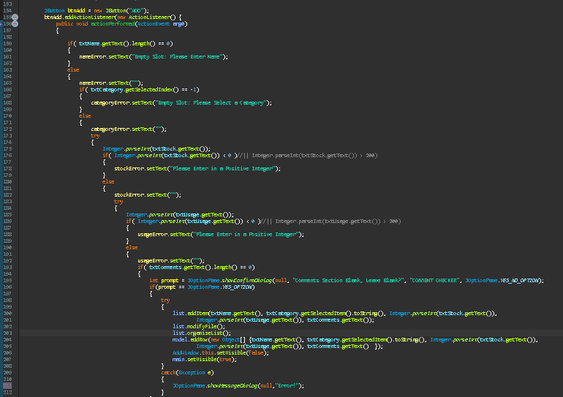

This image above shows the information being taken from the various JTextfields in the AddWindow class. Once all information is received the addItem() method is called with all the correct parameters passed in (the code is similar to the EditWindow class).

Deleting
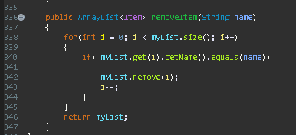
An Item is deleted using the removeItem() method in Methods class.
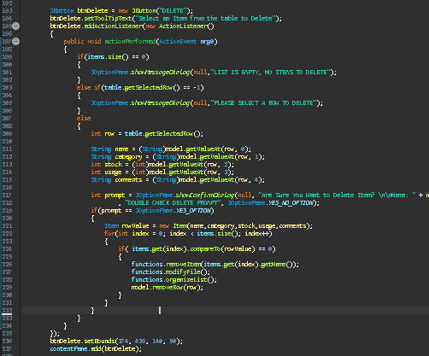
The Item is deleted by first having the user select a row, getSelectedRow(), in the JTable and then the values are searched within the ArrayList and once the Item is found the removeItem() method is called.

Searching
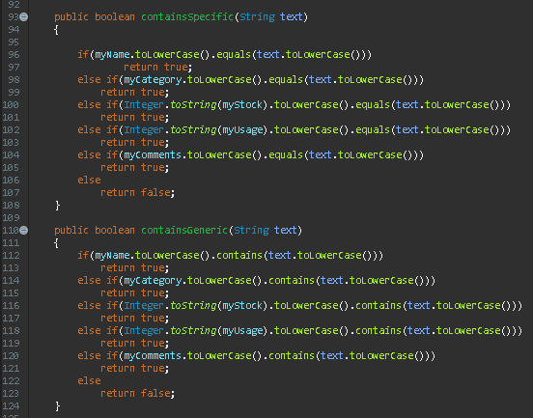
An Item is searched for using two method options found in the Item class: containsGeneric() or containsSpecific().

containsGeneric() searches for the Item by characters or digit that are contained within an Item, while containsSpecific() searches for the Item with the exact name or number.

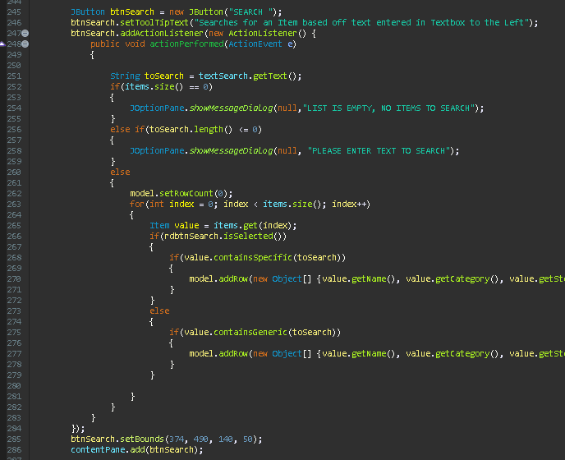
The Item is then searched using the text the user inputs into the JTextfield “textSearch” and the JTable is cleared and shows all Items containing the searched string.

Sorting
There are 6 different sorts:
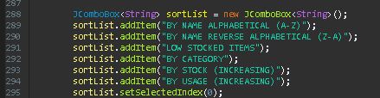

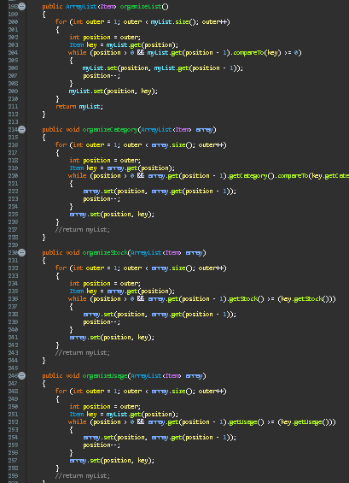
The sorts are found in the Methods class (seen on the right). The user first selects a sort from the JComboBox and the Items in the JTable are sorted according to the sort option selected.

Error Handling
User input errors are caught through a series try-catch methods that check if the user inputted data so that no parameters are empty. In addition, it checks if the information they inputted fits the specific parameter (such as if a String is inputted into one that requires an integer). If a user incorrectly tries to fill out the information, a series of JLabel will appear under the JTextfields instructing the user of what needs correction.
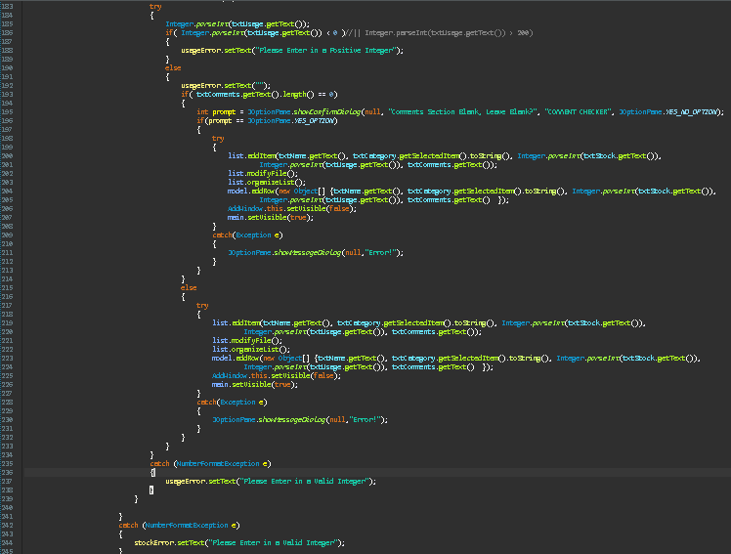
Below is the try-catch blocks taken from the AddWindow class, checking the user input and only adds the Item if all the input is correct.

